**EXP NO: 03**

**DATE: 13-04-24**

**Aim:**

Create a simple cloud software application for Car Booking Reservation System using any Cloud Service Provider to demonstrate SaaS include the necessary fields such as search for cabs, from, to, rental , out station, Package type, hours/Days etc.

**Implementation:**

**1. Go to Zoho.com and login/signup**

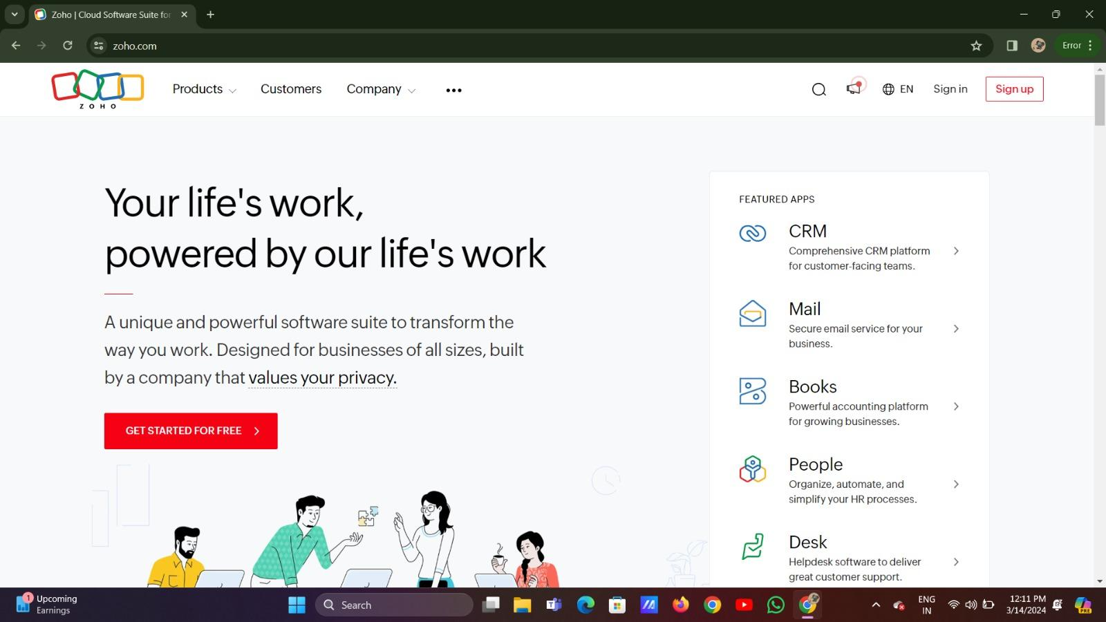

**2. Go to Creator**

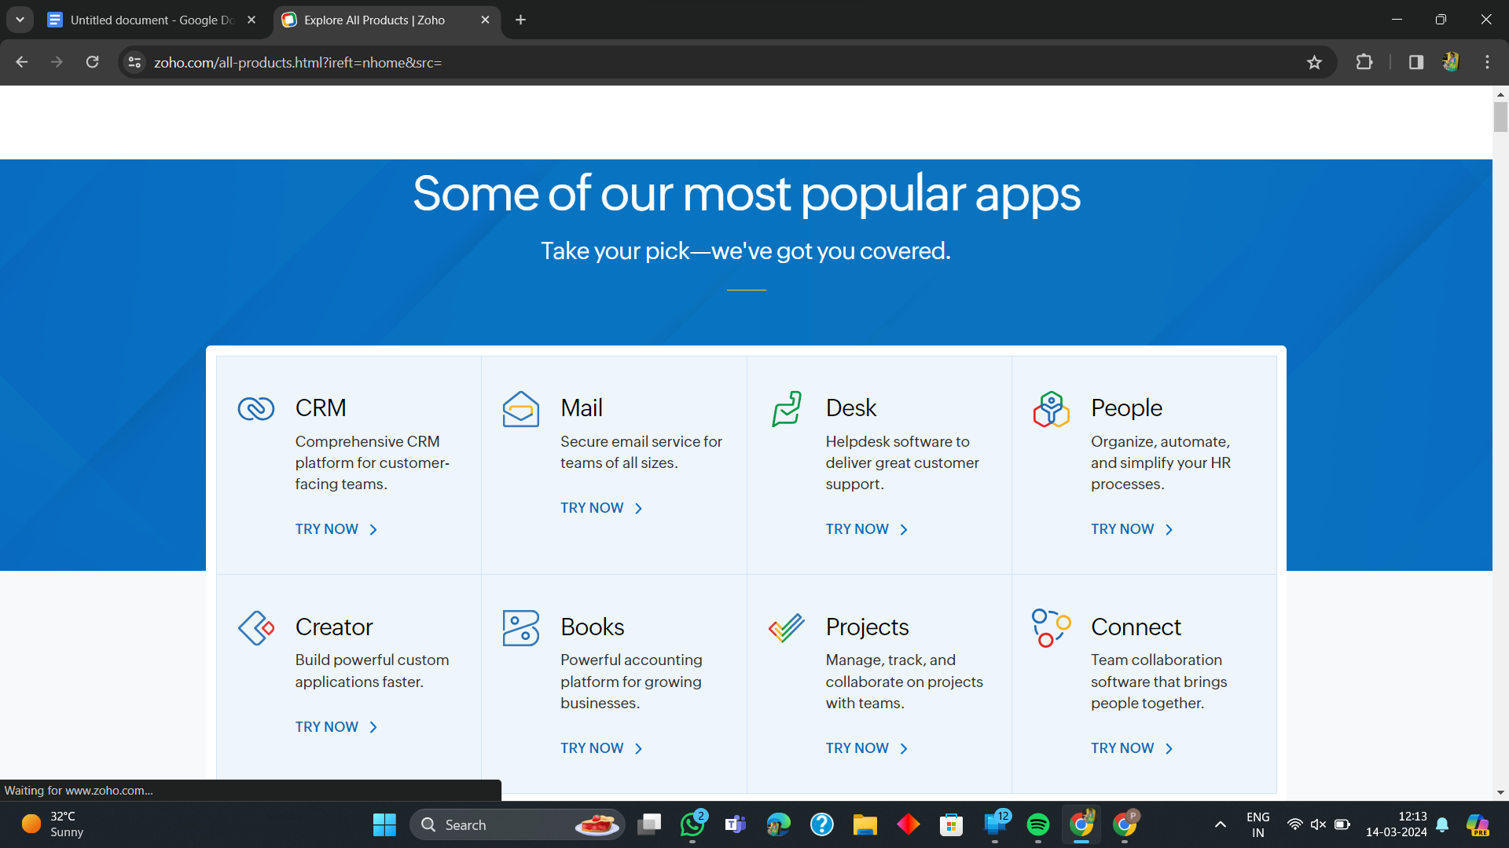

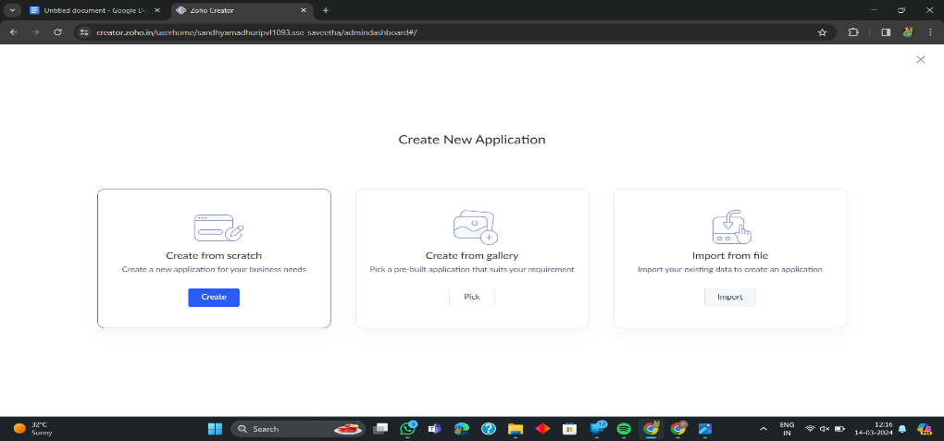**3. Create A New Application**

**4. Given Application Name**

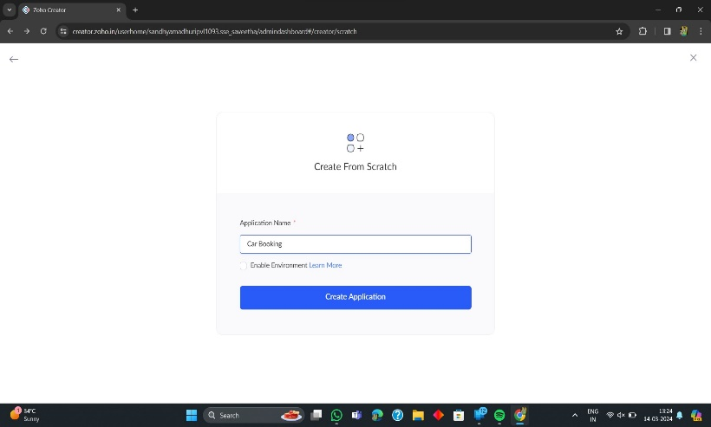

**5. Create New Form**

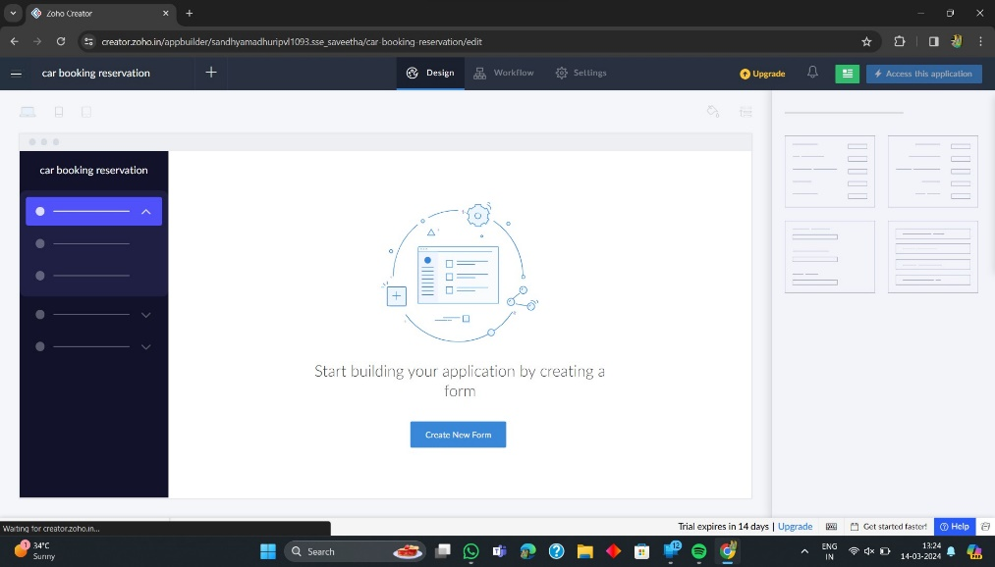

**6. Select Form and Give Name**

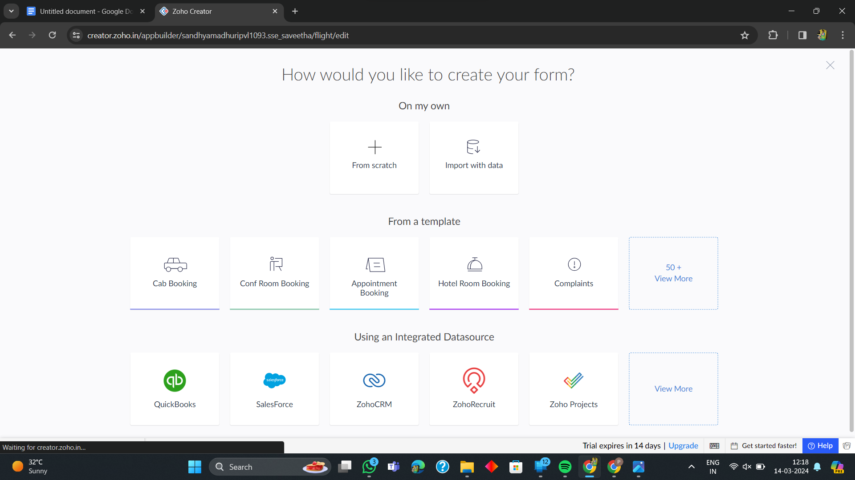

**7. Drag necessary fields**

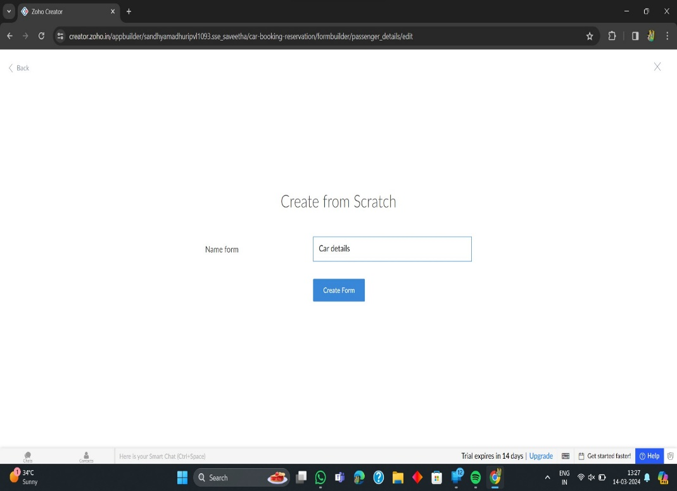

**8. The Software Has been created**

